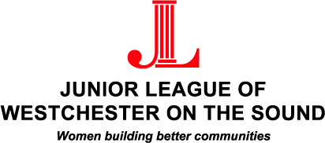

COMMUNITY GRANTS FUND APPLICATION 2022

Name of organization to which grant would be paid (please list exact legal name).
____________________________________________________________________________________
Address: ___________________________________________________________________________
Telephone: _________________________ Email address: __________________________________
Contact for inquiries and title: _________________________________________________________
Tax-exempt number: ______________________________
Date of application: _______________________________

Briefly describe your organization’s mission.

Describe the work of your organization. Address each of the following:

1. Need and people served
2. Current programs and accomplishments
3. Total number and titles of full-time and part-time staff
4. List of board members
5. Number of active volunteers
6. Volunteer opportunities offered

Please summarize the grant request. Address each of the following:

1. Program/Project goals & objectives
2. Expected outcomes by the end of the funding period
3. Method that will be used to measure the program/project’s effectiveness
4. Criteria for a successful program/project

Project/Program budget: Amount requested $ _________________
Please attach and/or describe below the program/project’s budget and dates covered.

Please list other community organizations from which you are seeking funds for this program/project.

1.
2.
3.

Has your organization had any prior affiliation with the Junior League of Westchester on the Sound? If yes, please describe.

Financial Documents

To be complete, applications must be accompanied by one copy of each of the following financial documents:

- Current Operating Budget
- Recent Audited Financial Statement (including auditor’s opinion letter)
- Tax-Exempt 501(c)(3) certificate (IRS tax-exempt determination letter)

Submission of Application & Supporting Financial Documentation

Email submission of completed applications and supporting financial documentation (in scanned PDF form) to grantsandscholarships@jlwos.org.

Applications must be received by March 11, 2022. Applications are not complete until all material and information is received.

* * *

I hereby declare that the above information is accurate to the best of my knowledge.

Signature of Executive Director: _____________________________
Title: _____________________________
Date: _____________________________

The Junior League of Westchester on the Sound thanks you for your commitment to helping the Sound Shore community.

